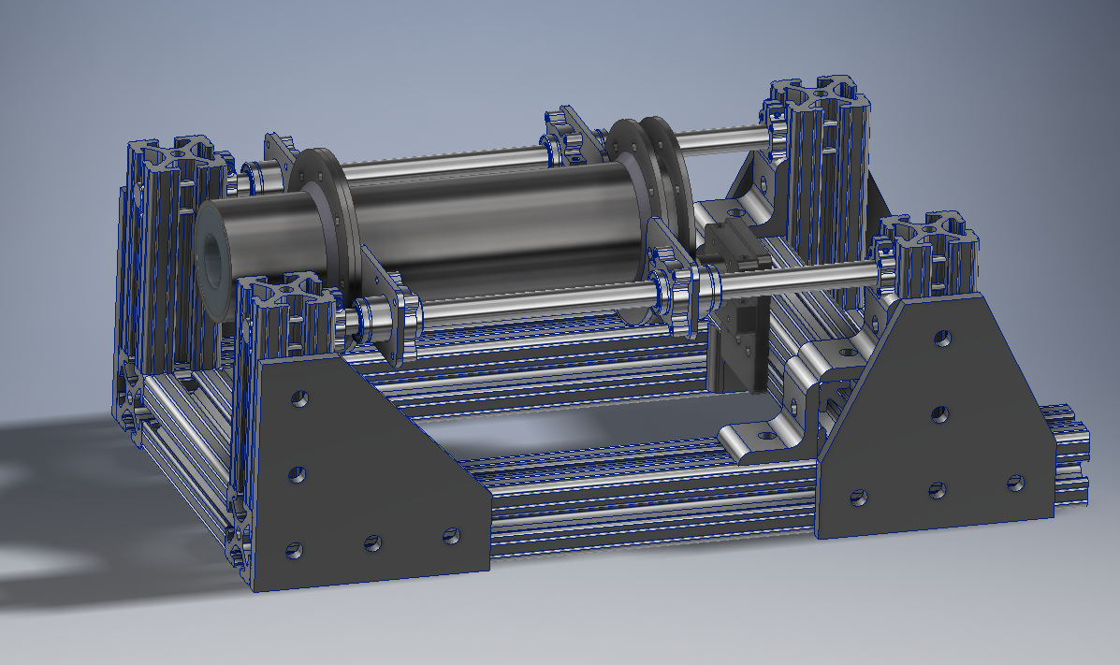

Design Philosophy

Frame Analysis

Displacement

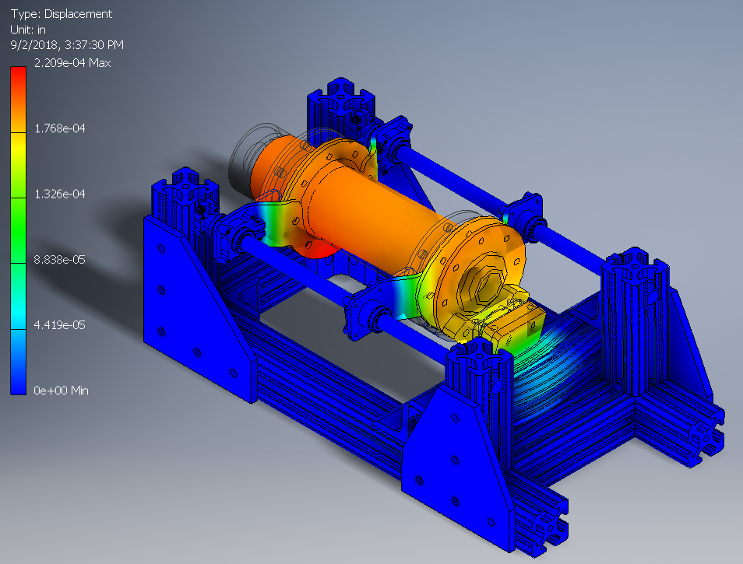

The displacement calculated under a 500N load on the nozzle results in minimal distortion of structural components. The primary motor support structure is designed to translate laterally, resulting in the load being transferred to the load cell and its mounting plate.

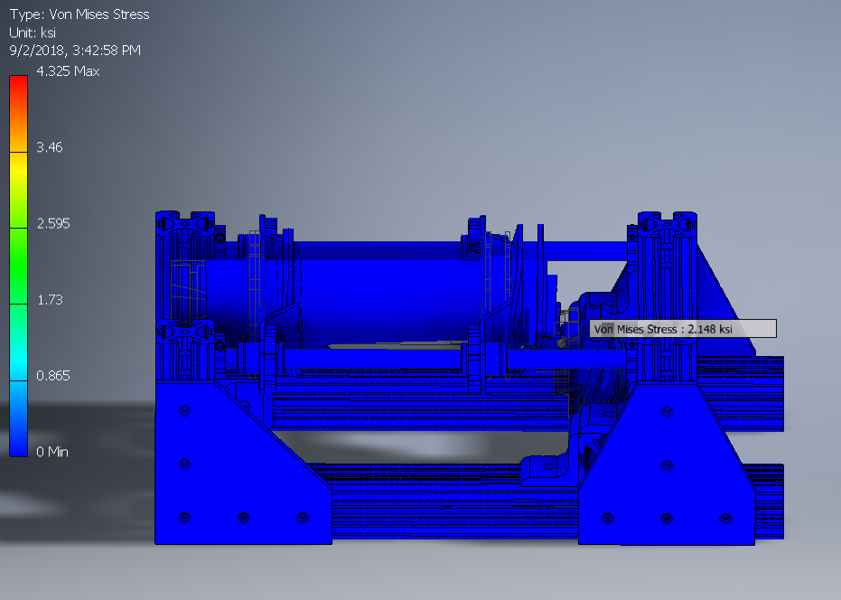

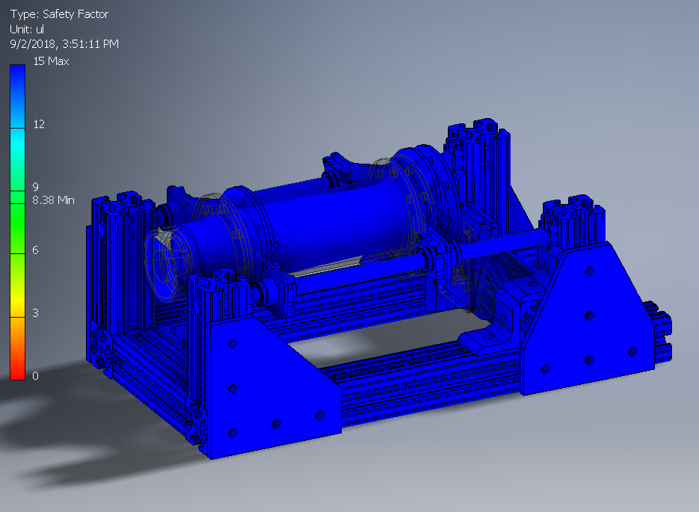

The FEA-calculated safety factor demonstrates that the structure is capable of withstanding loads much higher than the expected 500N of the first generation motor. The minimum SF was located on the load cell which is rated for loads far higher than what is expected from the motor

Motor Mounts

Load Cell